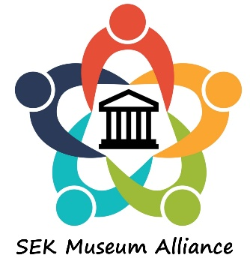
MINUTES SEK Museum Alliance Work Session
August 19, 2019
9:00 am – 11 am

Host: Parsons Historical Society & Iron Horse Museum
Parsons, KS

About 20 people who had indicated a willingness to help in the formation of a SEK museum alliance met in Parsons for a work session. The purpose of the meeting was to provide recommendations to the total membership at the next meeting, rather than to make decisions.

Ray Rothgeb led the discussion on the following topics:
- Alliance board
  - Number of members
  - How members are selected
  - Officers
  - Frequency of meetings
- General membership
  - 12-county region vs. 15-county region
  - Represetative
  - Frequency of meetings
  - Location of Meetings/meeting Logistics
- Purpose – Mission Statement

The recommendations of the group will be presented for balloting at the next general meeting.

