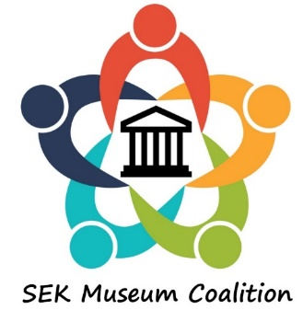
MINUTES SEK Coalition Meeting
June 15, 2019
9:00 am – Noon

Host: Independence Historical Museum & Art Center
Independence, KS

Ray Rothgeb, President of the board of the Independence Historical museum & Art Center, welcomed attendees. Leanne Githens of the Wilson County Historical Museum presented a proposed logo for the newly formed organization, and distributed papers for all to record particular challenges they are having in their museums.

Ray led round table discussions on how to proceed as an organization. Attendees were divided into 3 groups to provide input on the following topics:
- Purpose – What is the SEK Coalition about?
  - Education, Support, Lobbying, Promotions, etc.??
- Governance – Who is in charge of the SEK Coalition?
  - An elected board, a representative board, no board, funding if needed??
- Where and when will the SEK Coalition meet?
  - Location, frequency, meeting days??

Reports from each round table topic were given. Ray and Leanne will review the reports and meet with some of the people that have volunteered to help in formalizing the structure of the organization.

Attendees were asked to fill out a meeting response form to provide more specific input.

Lunch was provided by the volunteers of the museum, and individuals toured the museum.

